1. **INTRODUCTION:**

**1.1 OVERVIEW:**

**Economic freedom is the fundamental right of every human is to control his or her own Labour and property. Economic freedom means that people can engage with any person of their choosing. If the Government taxes or otherwise prevent people from buying or celling from other countries, it reduces our economic freedom. In economically free society, individual are free to work, produce, consume and invest in any way they please.**

**For much of human history people have lacked economic freedom and opportunity. In 2022, the principle of economic freedom that have fueled monumental progress are again measured in economic freedom.**

**1.2 PURPOSE:**

**Economic freedom means people can engage with any person of their choosing. Individuals have economic freedom when property they acquire without the use of force, fraud, or theft is protected from physical invasions by others and they are free to use, exchange, or give their property as long as their actions do not violate the identical rights of others. Individuals have economic freedom when property they acquire without the use of force, fraud, or theft is protected from physical invasions by others and they are free to use, exchange, or give their property as long as their actions do not violate the identical rights of others.**

**2. PROBLEM DEFINITION & DESIGN THINKING:**

**2.1 EMPATHY MAP:**

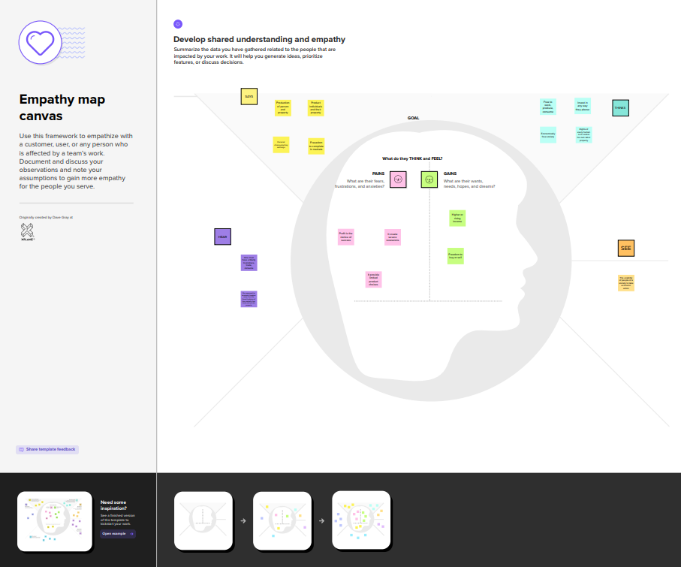

**2.2 IDEATION AND BRAIN STROMING:**

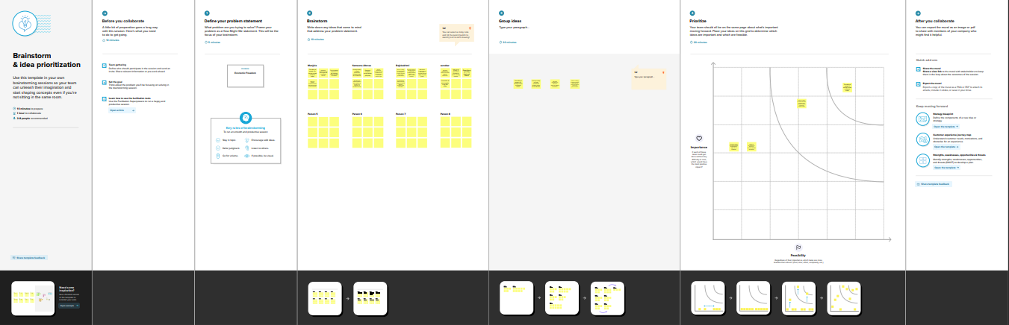

**3.RESULT :**

**3.1 AMOUNT OF DATA RENDERED TO DATA BASE:**

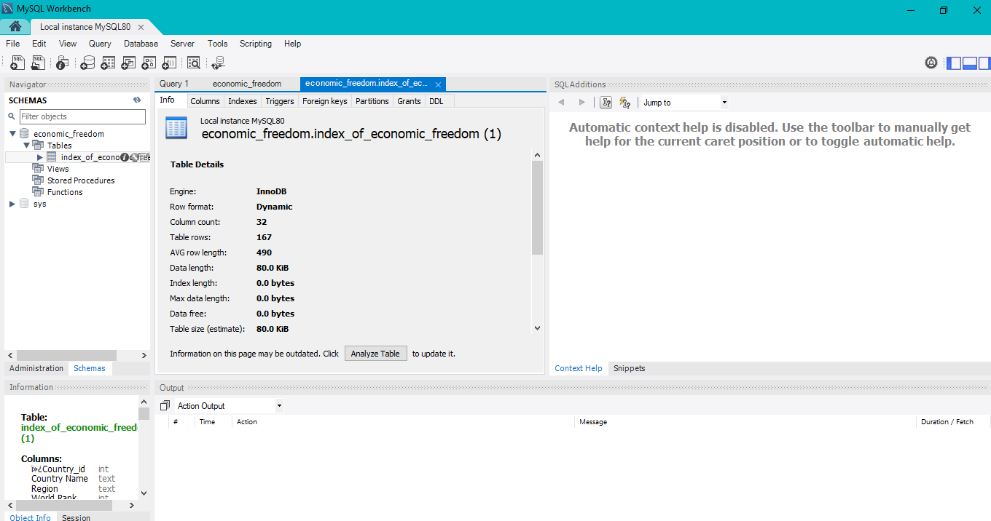

**3.2 UTILIZATION OF DATA FILTERS:**

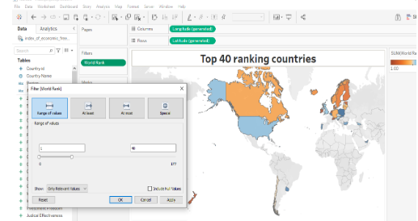

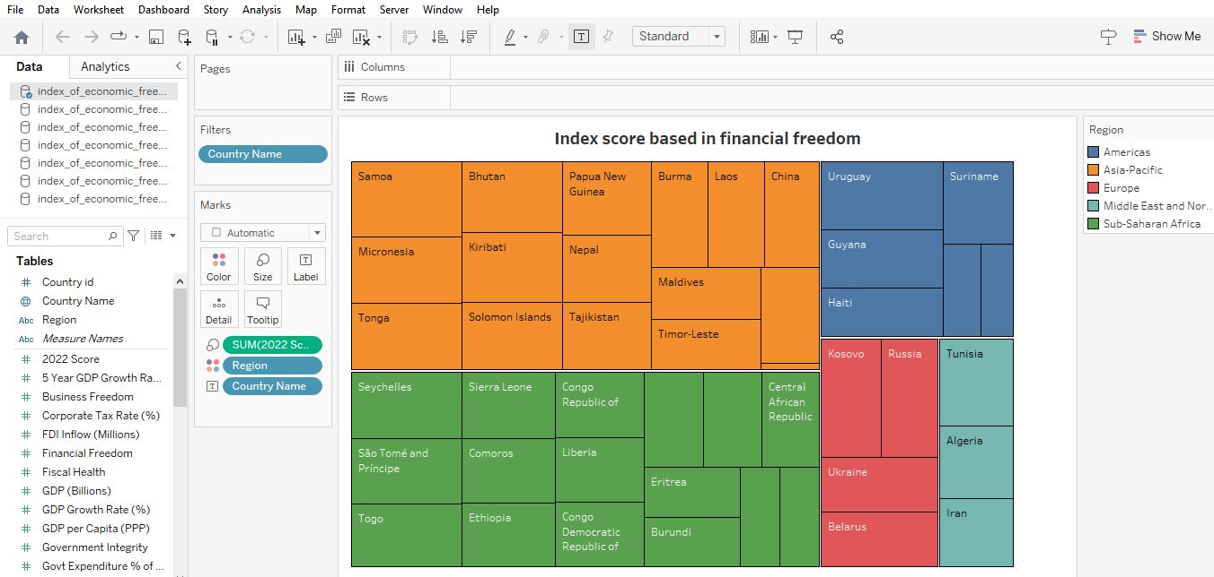

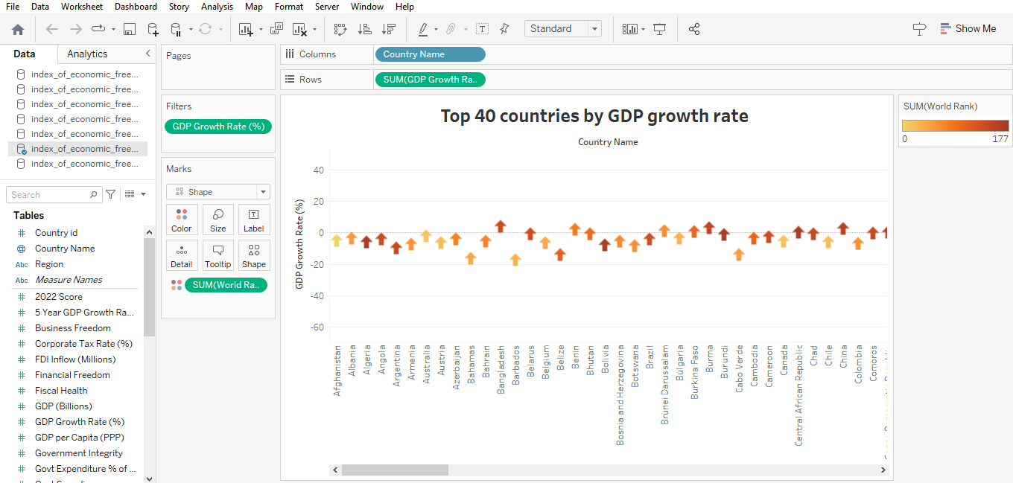

**3.3 CALCULATION FIELDS:**

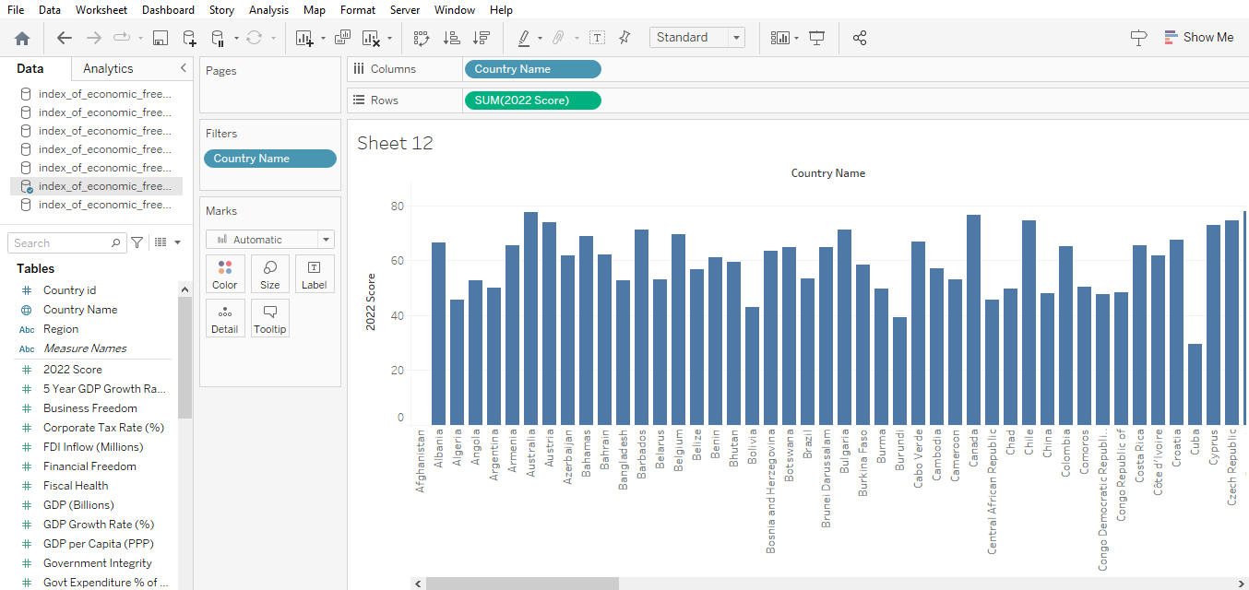

**3.4. 2022 ECONOMIC FREEDOM SCORE:**

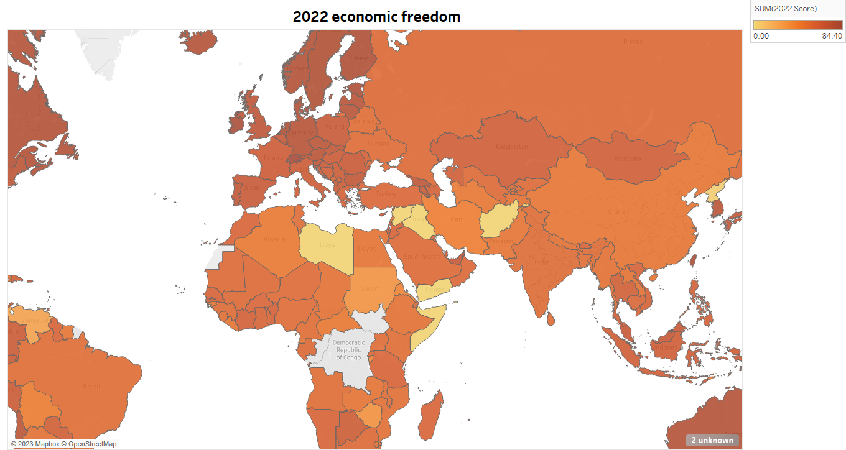

**3.5. TOP 40 RANKING COUNTRIES IN THE INDEX :**

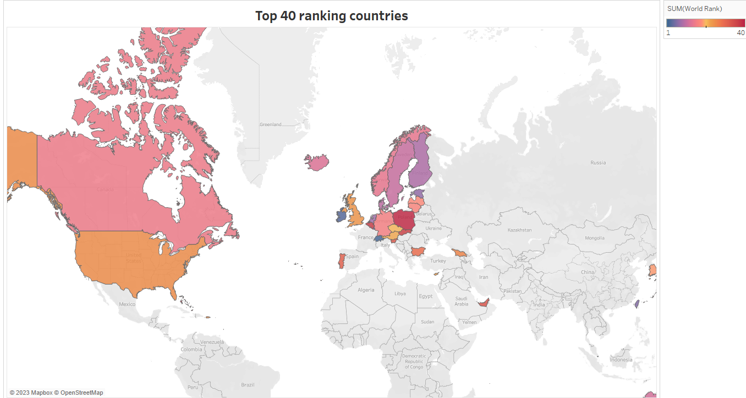

**3.6. BOTTOM RANKING COUNTRIES IN THE INDEX :**

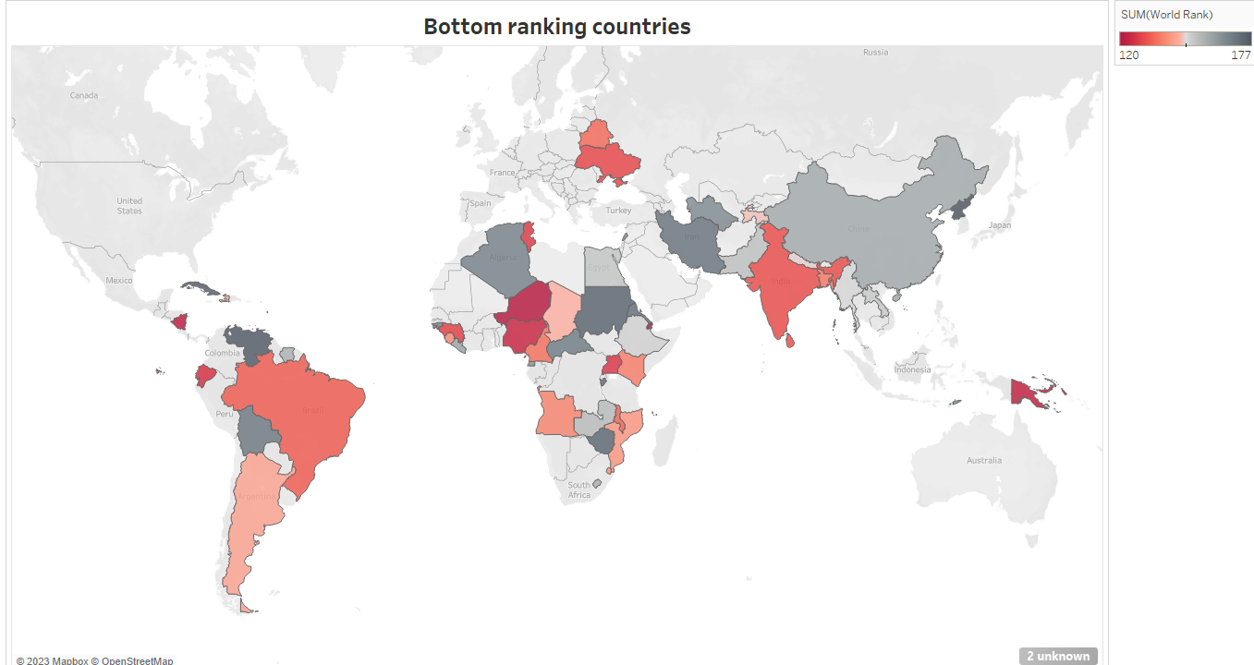

**3.7. INDEX SCORE BASED ON UNEMPLOYMENT RATE :**

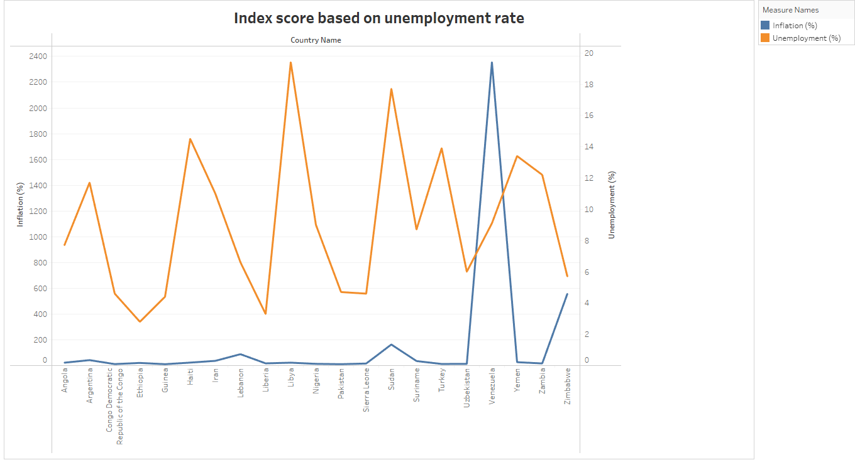

**3.8. INDEX SCORE BASED ON FINANCIAL FREEDOM :**

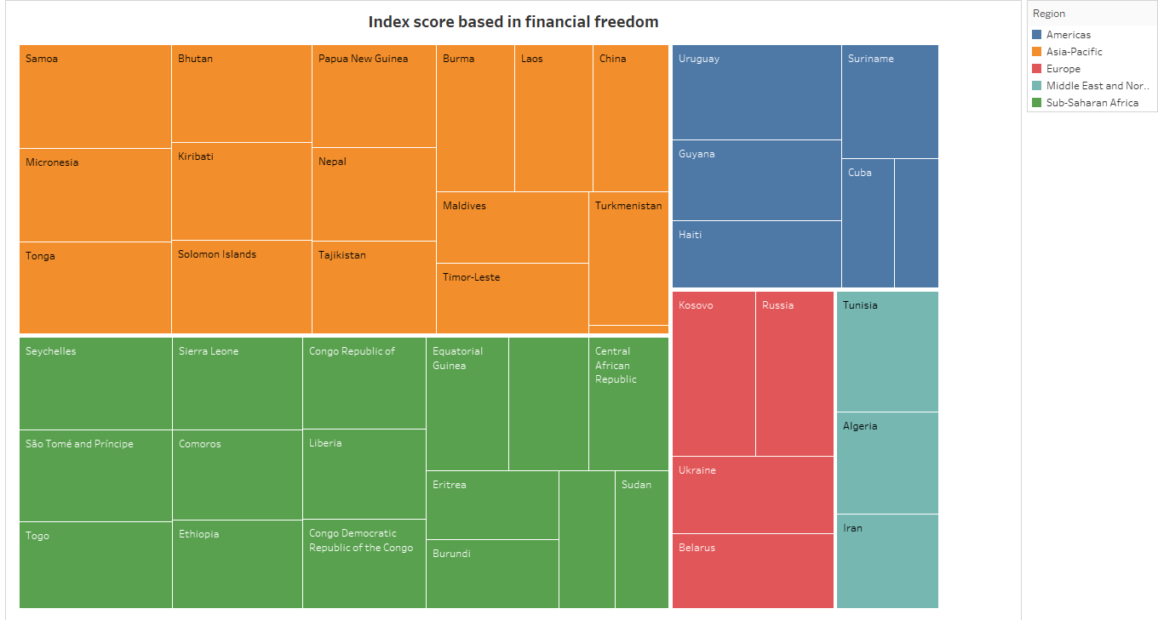

**3.9 INDEX SCORE BASED ON POPULATION :**

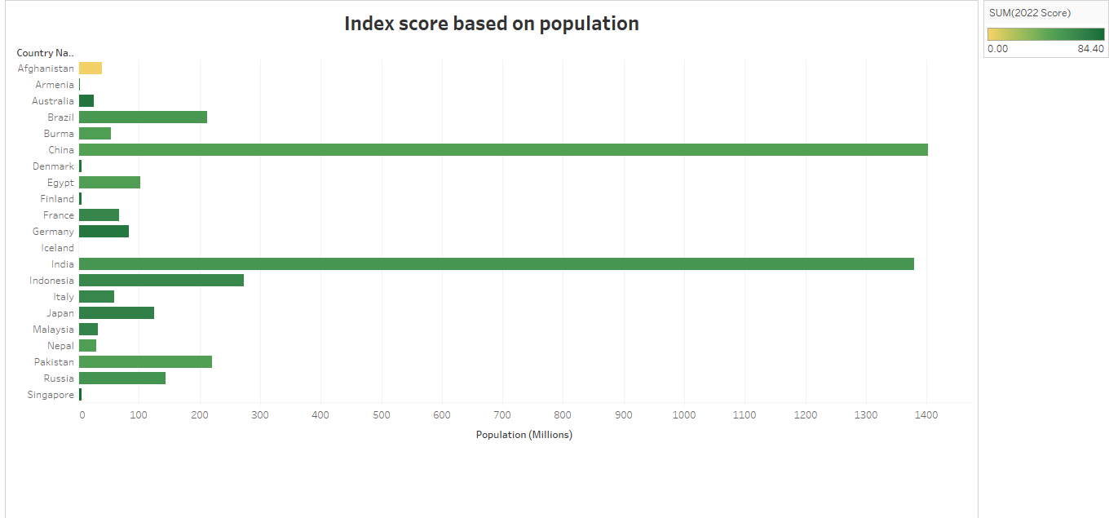

**3.10 . INDEX SCORE BASED ON 5 YEARS GDP GROWTH RATE % :**

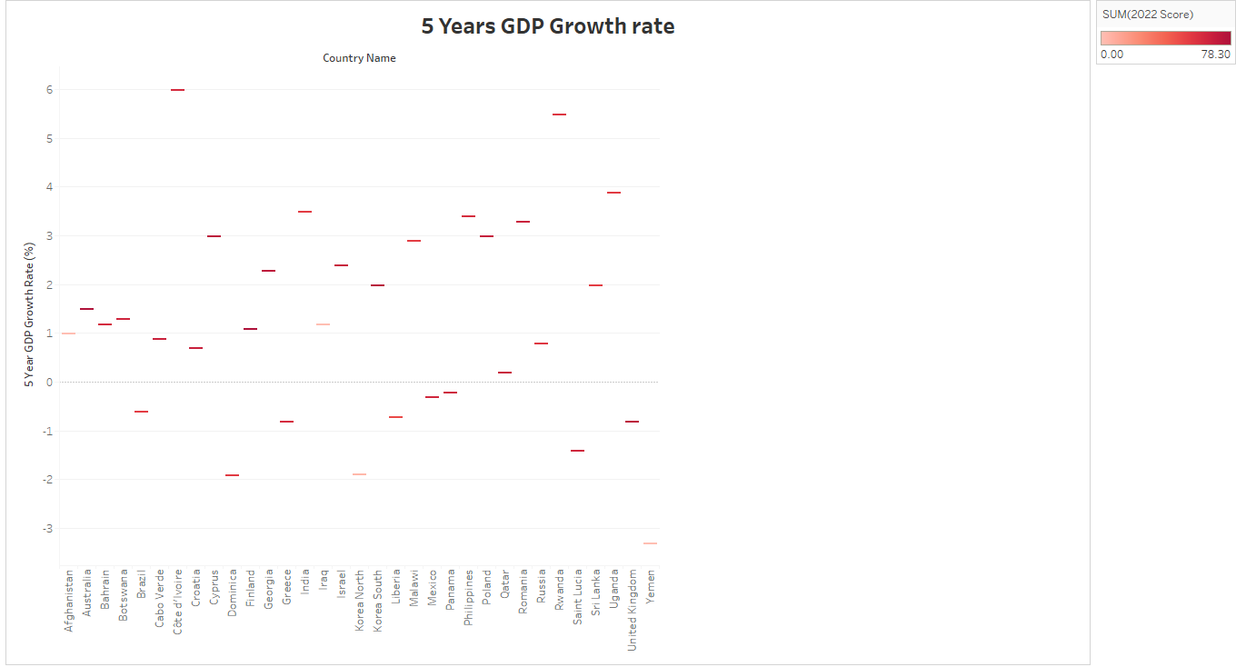

**3.11.INFLATION RATE IN DIFFERENT COUNTRIES :**

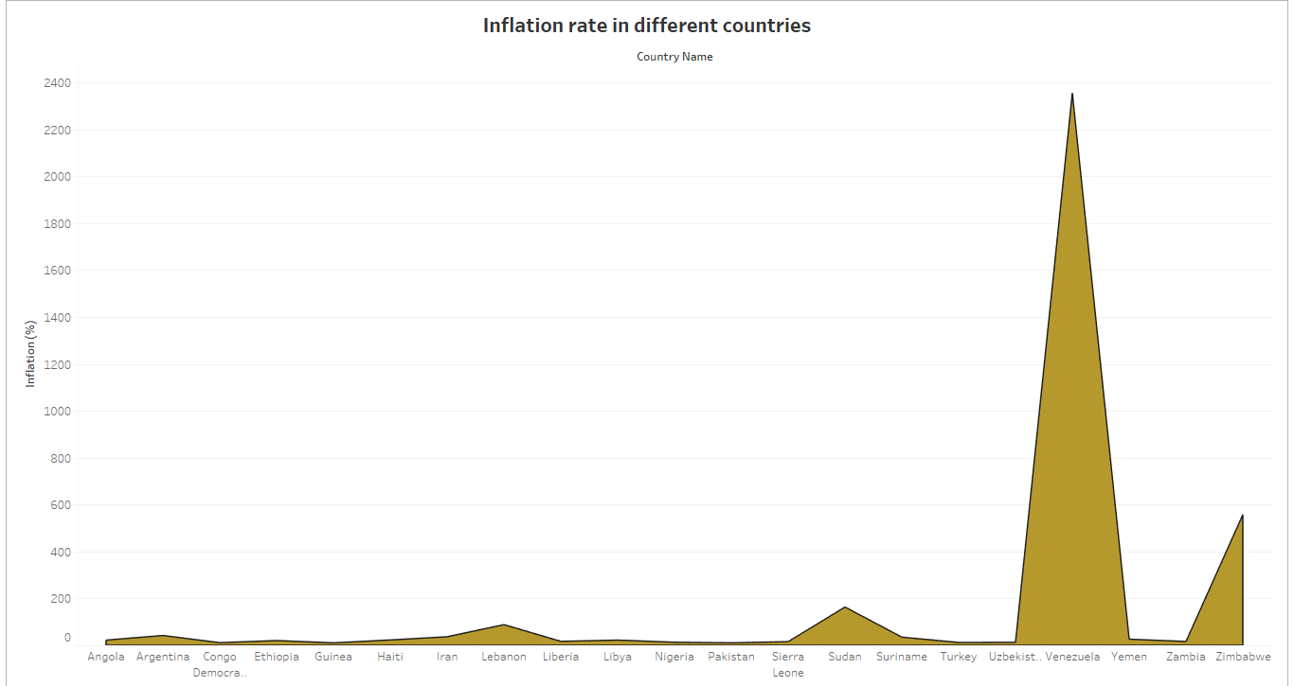

**3.12. CORRELATION BETWEEN INFLATION AND UNEMPLOYMENT :**

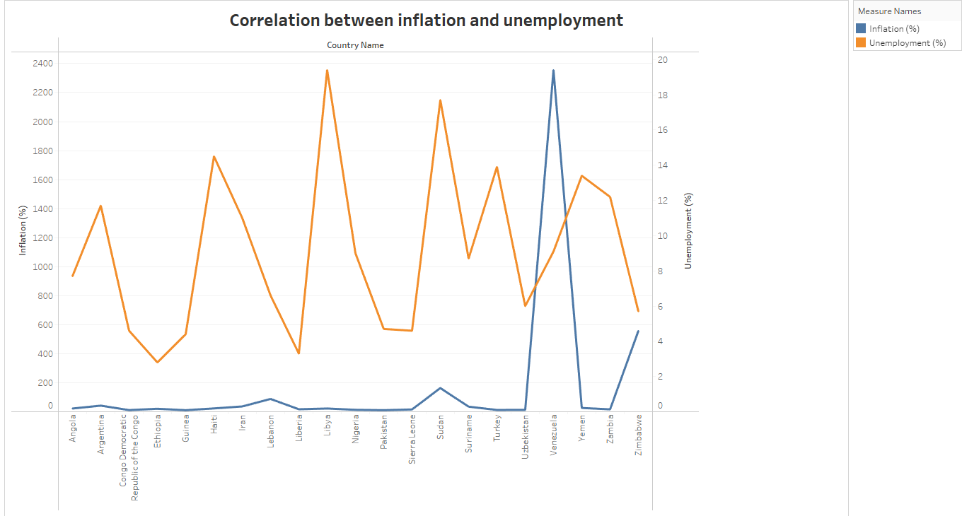

**3.13. CORRELATION BETWEEN GDP (PPP) AND MONETARY FREEDOM :**

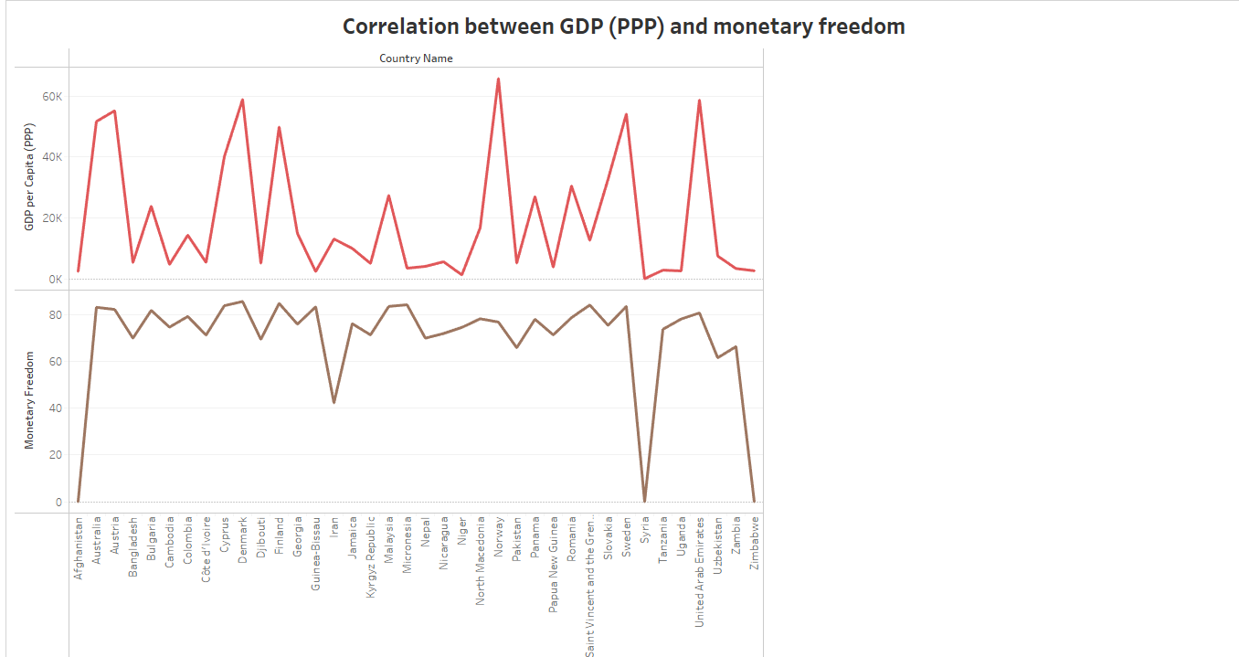

**3.14. TOP 40 COUNTRIES BY GDP GROWTH :**

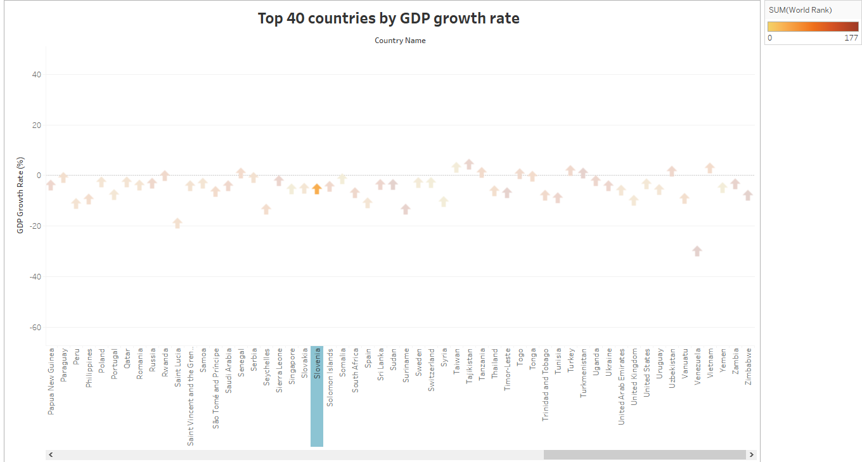

**3.15.DASHBOARDS :**

**1.**

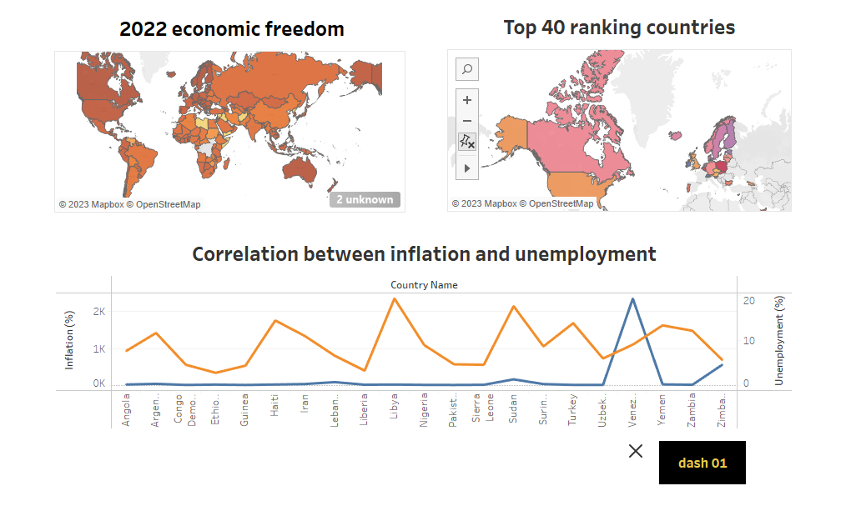

**2.**

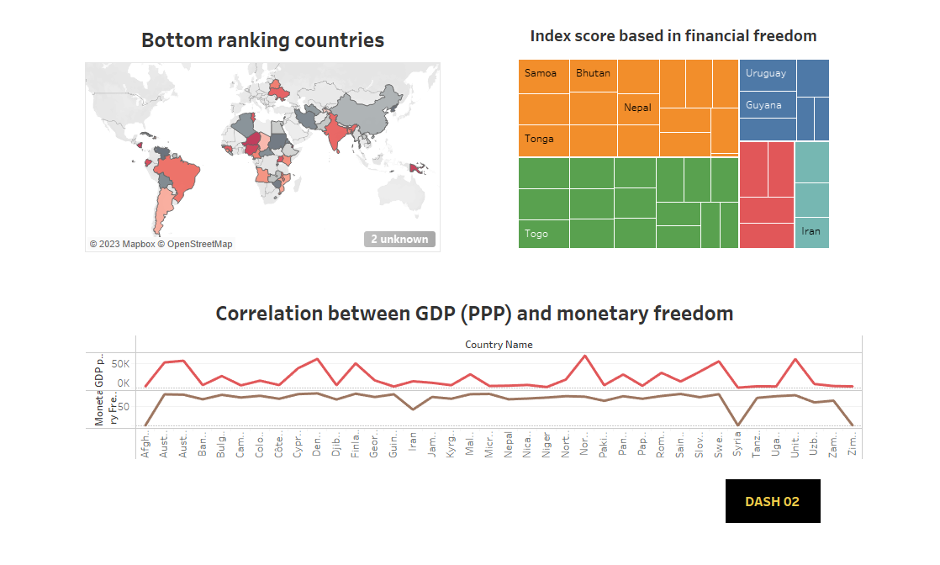

**3.**

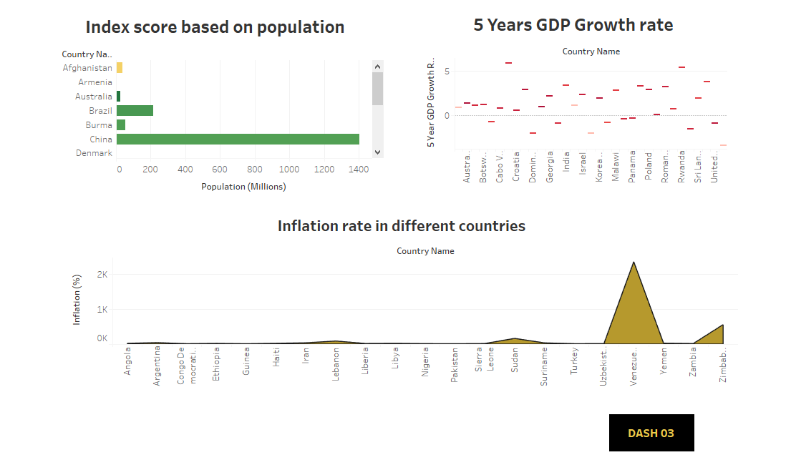

**4.**

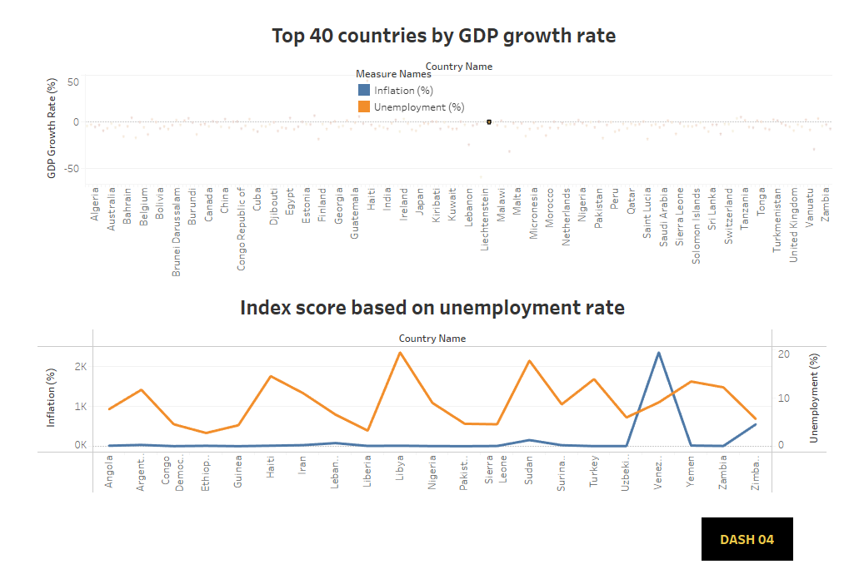

**3.16 STORY :**

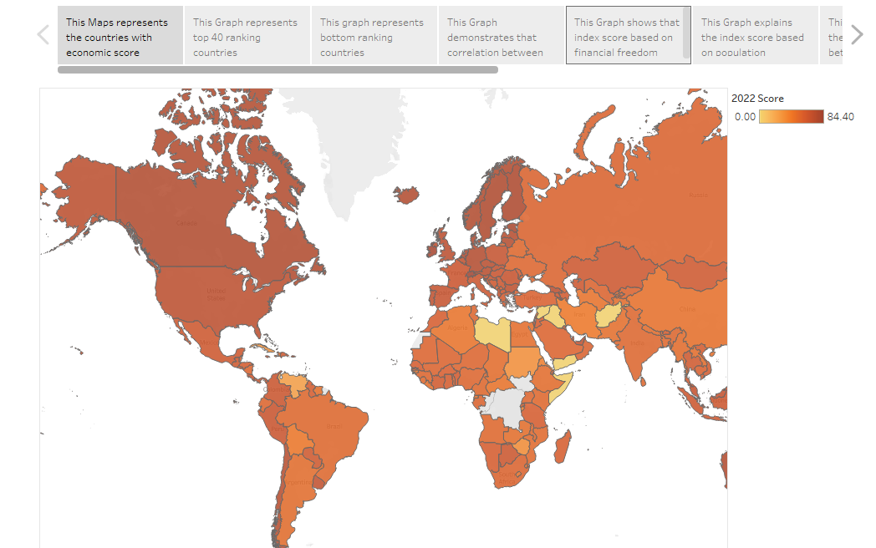

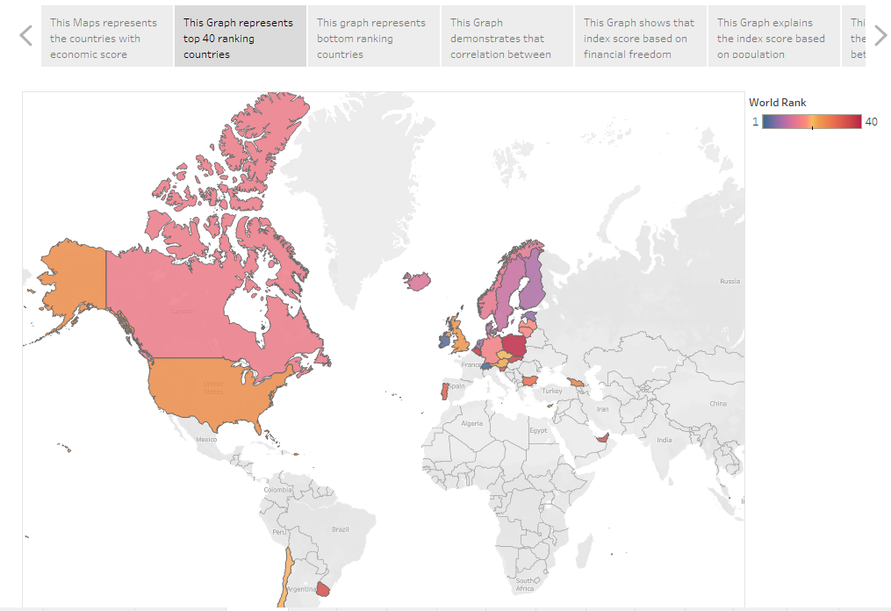

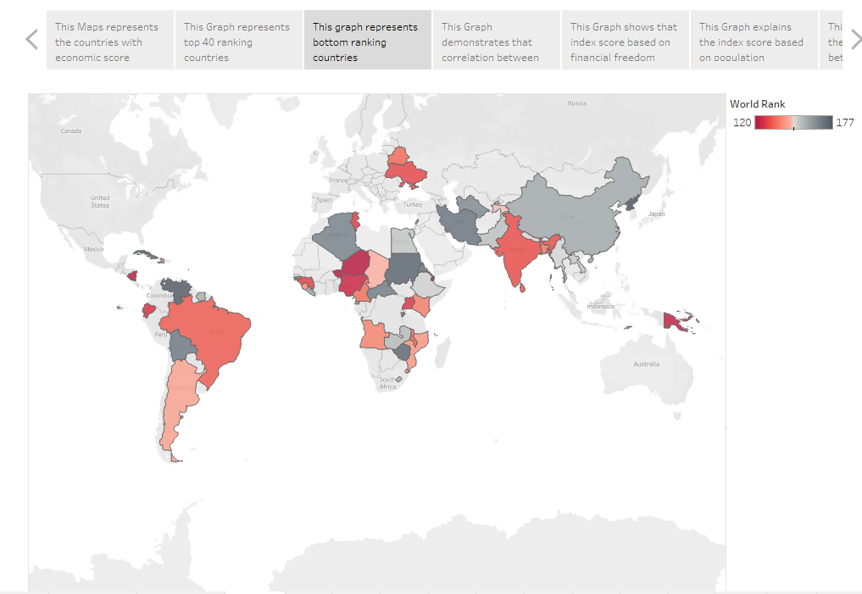

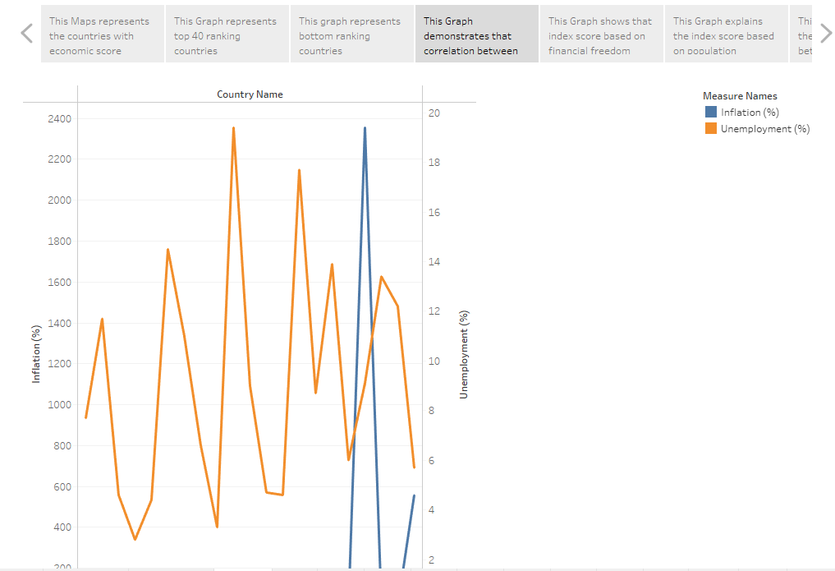

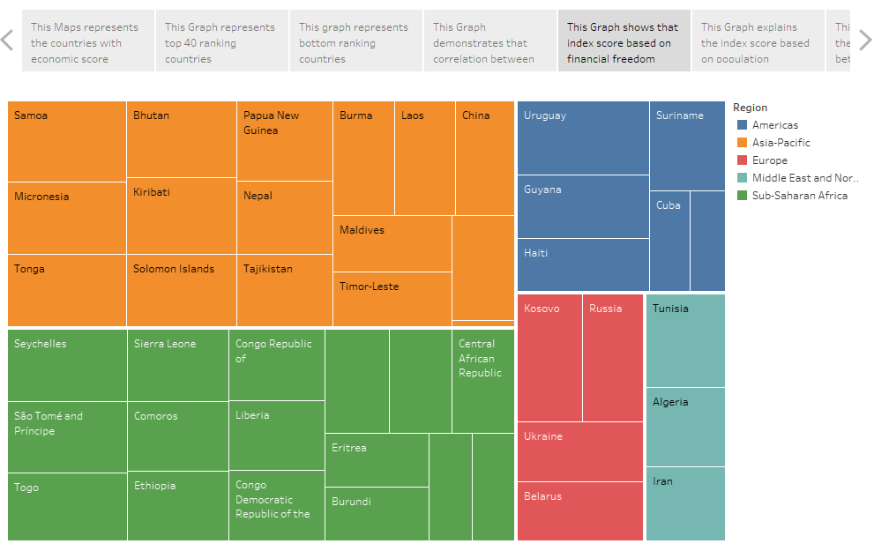

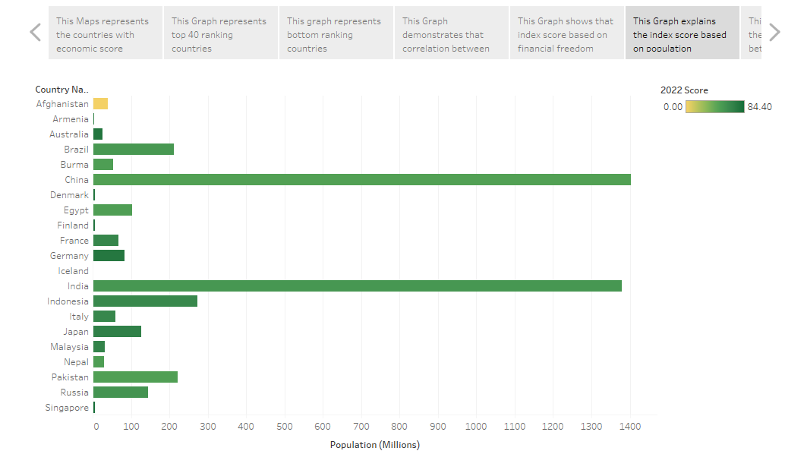

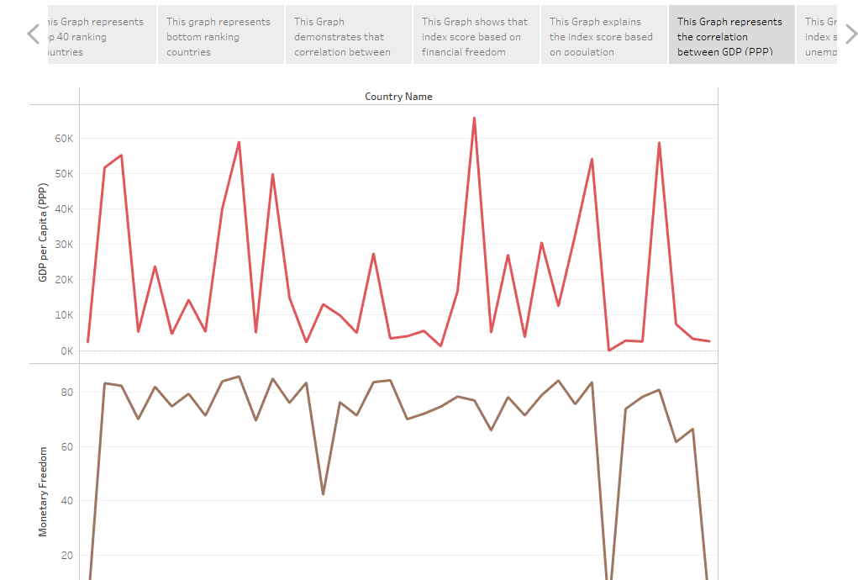

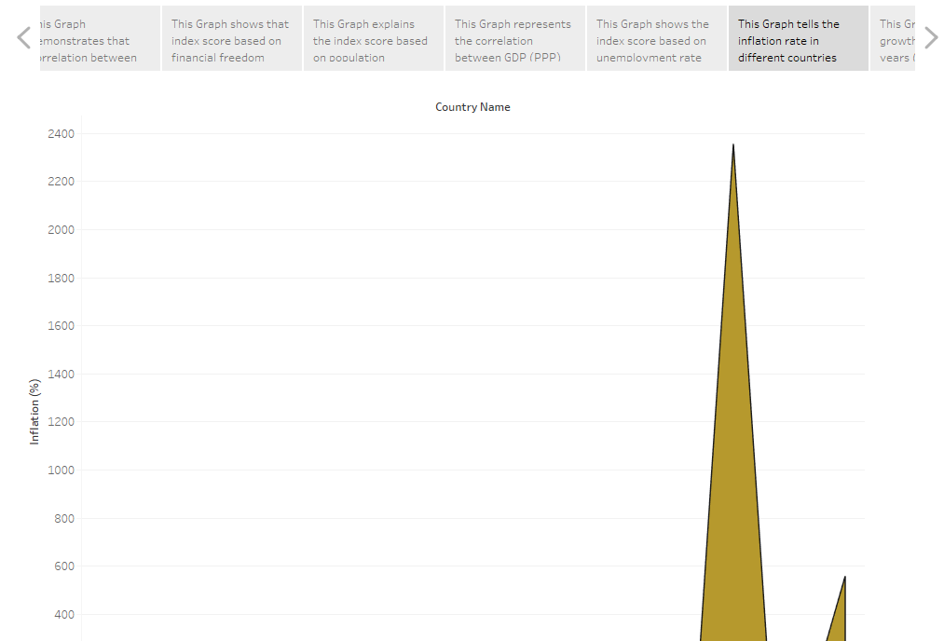

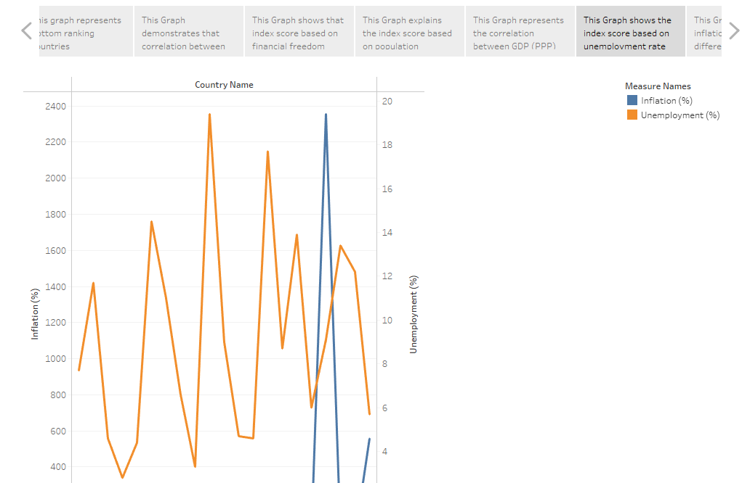

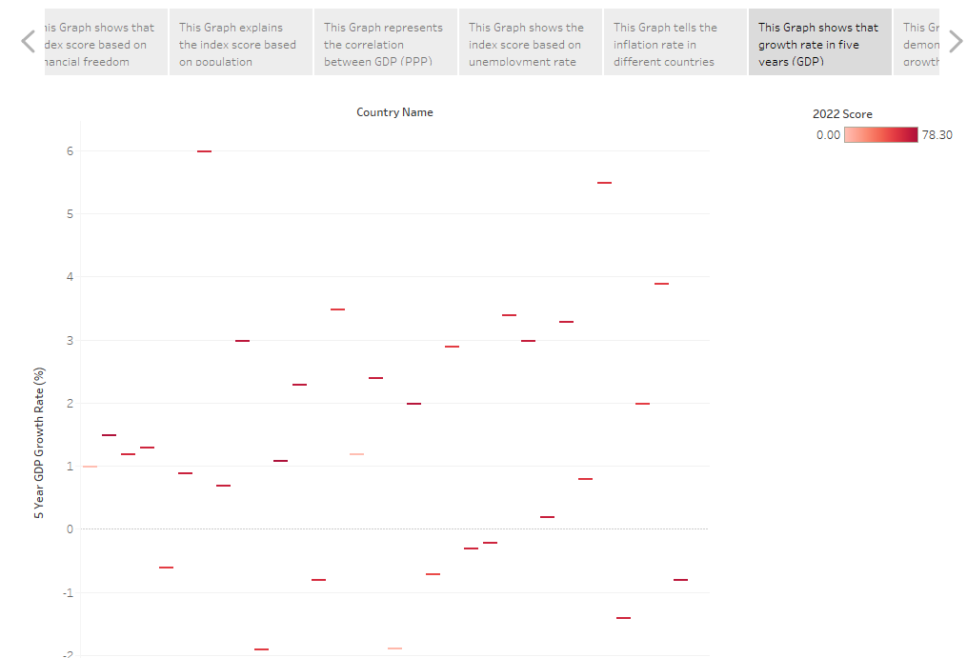

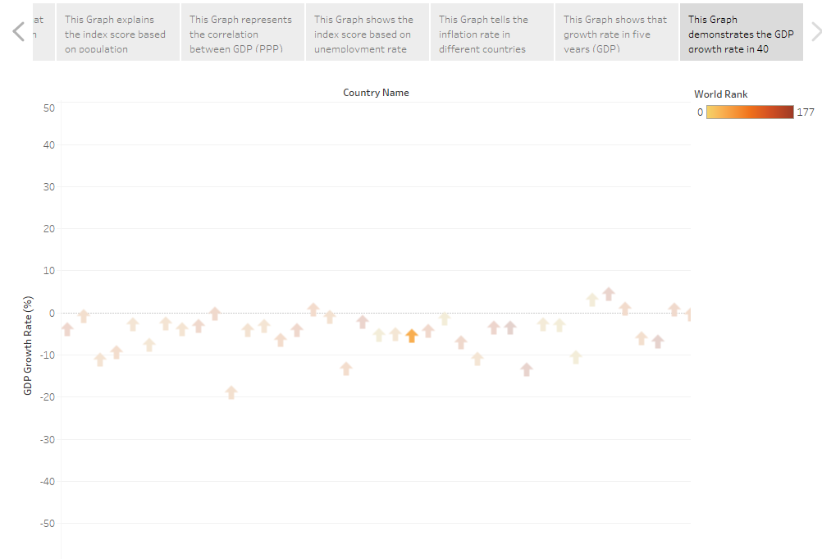

4.ADVANTAGES AND DISADVANTAGES :

**4.1. ADVANTAGES:**

* **Increased efficiency.**
* **Productivity.**
* **Fair competition.**
* **Innovation.**
* **Coustumer satisfaction.**
* **Profit.**

**4.2. DISADVANTAGES:**

* **Poor quality.**
* **Since profit maximization is the biggest motivation for firm, they may try to reduce their costs unethically.**
* **Merit goods.**
* **Good and Services that are not profitable will not be produced or run.**
* **Excessive power of firms.**
* **Unemployment.**

**5.APPLICATIONS:**

* **In economics, the freedom of choice is the freedom of economic agents to allocate their resources as they fit along the option such as goods, services or assets that are available to them.**
* **It also includes the freedom to engage in employment available to them.**
* **Individual have economic freedom when property the acquire without the use of force or theft id protected from physical invasions by others and they are free to use.**
* **Their property as long as their action do not violate the identical rights of others.**
* **Economic systems regulate the factors of production, including land, capital, labour, and physical resources.**
* **An index of economic freedom is a composite measure of the political economic institutions across different jurisdiction.**

**6.CONCLUTION:**

**As time goes on, these measures of economic freedom will improve and our understanding of the relationship between private property and free markets and economic performance will similarly improve. But in the great debate between economic freedom and political planning, the evidence is increasingly clear.**

**Economic freedom leads to better economic results.** **While there is no clear evidence that economic freedom creates greater income inequality, there is clear evidence that lowest-income people in freer countries are better off than their counterparts in less free countries.**

**It observed that far as the employment generation is concerned, the induced effect of domestic use and trade are in opposite direction, but the interesting fact is the trade contribute to positive employment growth of the economy. As far as value id added is concerned, both domestic demand and trade stimulated. Economic growth enables the economy to have more of both goods.**

**7.FUTURE SCOPE:**

* **Economic goals are not always mutually compatible. The ultimate goal of economic science is to improve the living conditions of people in their everyday lives. They want to have the freedom to choose their jobs, their firms and the way they use their earning.**
* **India is the world seventh largest economy, sitting between France & Italy. Its GDP growth rate recently dipped into 5.7%.**
* **India is growing faster than any other large economy except for China.**
* **Economic scope is an economy theory stating as a result of increasing production decreases as a result of increasing number of different goods produced.**
* **For example, a gas station that sells gasoline, can sell soda, milk, baked goods etc.**
* **These seven goals are economic freedom, economic equality, economic security, economic growth, economic efficiency, price stability and**